Motutapu Outdoor Education Camp, Administration Bay, Motutapu Island
Environmental Impact Overview for Ngāi Tai Ki Tāmaki

Draft 2
3 July 2023

Contents
1 Introduction 3
2 Site 4
3 Heritage 5
4 Cultural Heritage 6
5 Ecology 7
6 Wastewater 8
7 Stormwater 9
8 Potable Water 10
9 Refuse 11
10 Noxious Weeds 12
11 Natural Hazards 13
12 Island-wide Infrastructure 14
13 Community Education 15
14 Cumulative Effects 16

Introduction

  - This is an Environmental Impact Overview of the environmental impacts of the outdoor education camp on Motutapu Island at Administration Bay.

  - This overview has been produced in support of an application by Ngāi Tai Ki Tāmaki Trust for a concession to operate the camp as a youth outdoor education facility.

  - The outdoor education camp is the adaptive reuse of the former WWII military barracks at Administration Bay. It has been used as a youth camp since the late 1960s.

  - Ngāi Tai Ki Tāmaki is seeking a concession to continue to operate the camp in partnership through a management agreement with the Motutapu Outdoor Education Camp Trust.

  - This assessment is an overview of the environmental impact of operating a camp at the site.

.

Site

  - The artillery barracks at Motutapu was developed between 1936 and 1939. This development set in place the majority of the buildings currently comprising the site, the roading network, and other core infrastructure.

  - In the intervening period, particularly since the 1980s, there have been a series of upgrades to the camp which have added additional buildings, but within the development confines of the artillery facility, and outdoor education equipment (such as climbing towers and high ropes).

  - There have also been significant upgrades to the infrastructure, particularly potable water, wastewater and stormwater.

  - This assessment examines different aspects of the operation and the environmental impact.

  - The diagram below is a map of the subject site

Diagram 1 Site Map
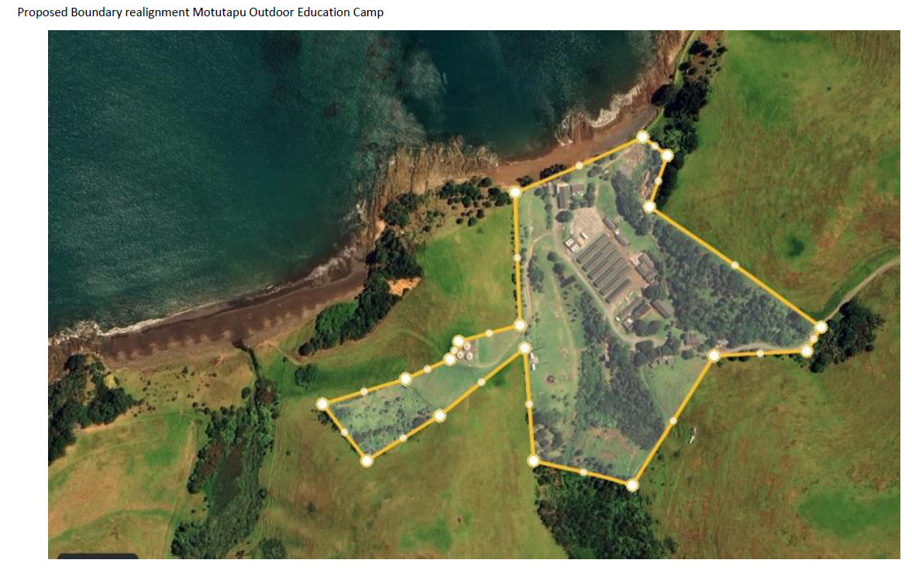

  - The camp is a permitted activity under the Hauraki Gulf Island District Plan. Rule 10a.25.5 states “Education facilities on Motutapu for up to a maximum of 250 persons for the Motutapu Outdoor Education Camp” is a permitted activity.

  - The Auckland Conservation Management Strategy 2014-2024 at section 19.2.2.21 sets the following policy for Motutapu island:
“Support the operation of the Motutapu Outdoor Education Camp to enable the maintenance of the historic military complex at Administration Bay, and as a place to provide outdoor education experiences.”

Heritage

  - The camp is recognised as a heritage facility. It is given a Category 1 rating under the Pohere Taonga Heritage New Zealand classification.
  - Motutapu Outdoor Education Trust (MOET), as part of their 2000-2023 concession, prepared and implemented a Heritage Conservation Management Plan. That plan was endorsed by the Department of Conservation (DOC).
  - The heritage elements of the camp have been managed in accordance with that plan.
  - The Conservation Management Strategy identifies the appropriateness of the adaptive reuse of the camp for a youth education facility.
  - All heritage buildings have been maintained in accordance with Heritage Conservation Management Plan. This has included replacement of rotten timbers, repair of windows and implementation of a robust maintenance and painting programme.
  - Ngāi Tai Ki Tāmaki supports the preservation of heritage and, as part of its concession application, will manage the site in accordance with the Conservation Management Plan for the site.
  - The heritage effects of this proposal are positive. The future of these buildings rely on adaptive reuse to give an economic activity to enable preservation of the buildings. The Conservation Management Plan supports the adaptive reuse of the site for a youth outdoor education camp. The concession agreement ensures the buildings are managed in an appropriate manner.

Cultural Heritage

  - Ngāi Tai Ki Tāmaki will bring an equal focus on the cultural heritage to this site.
  - Through matters including education, briefing of client groups, use of Te Reo in naming, and in ensuring protection of the key cultural aspects of Motutapu; Ngāi Tai Ki Tāmaki, through this concession, will enhance the cultural and cultural heritage values of the island.
  - One of the key benefits of this concession is the ability of Ngāi Tai Ki Tāmaki to both inform the physical work including maintenance within the camp, and to champion cultural heritage on the broader Motutapu Island including this site.

Ecology

  - Motutapu Island benefits from being pest free. DOC runs a rigorous programme to ensure retention of the pest free status.
  - MOET operates the camp fully in accordance with the pest free requirements of DOC.
  - DOC protocols set pre-conditions for visitors to the island. These are and will continue to be strictly applied to all clients and visitors.
  - This concession application will continue the protection and enhancement of this pest free status.
  - MOET since its inception, has enforced a strict no take policy on its clients / visitors in terms of fish, shellfish, other sea life, and other beach items within Administration Bay.
  - There is significant use of the bay by campers. These are in the activities of sailing, kayaking, paddle boarding, snorkelling and swimming. The only motorised vessels within the bay are the rescue craft associated with on water activity. The use of the bay for these craft has minimal impact on the ecology of the bay.
  - Bird life is well established within the concession area. The camp enforces requirements of no interference with bird habitat. Bird life has adapted to habitat close to the intensity of the youth camp.
  - The environmental effects in terms of the marine environment are successfully managed through a combination of the no take policy and the operational practises of the camp. These ensure that the effects are minimal in terms of the impact of activity and beneficial in terms of the no take policies.

Wastewater

  - The camp has a full wastewater treatment system. This involves:
- the separation of wastewater and stormwater;
- all wastewater goes through a treatment process involving sludge tanks, evaporation, beds and driplines before a land discharge;
- this facility is monitored on a regular basis with full removal of sludge to the mainland at least twice per annum.
  - MOET holds all necessary resource consents from Auckland Council with the latest consent being granted in 2022. This involved a full review of the system and the determination through the Council’s independent regulatory process, that it is fit for purpose and appropriate.
  - The wastewater system has a full monitoring and alarm system to identify any interim failures in the system. MOET holds maintenance contracts with technical specialists to ensure quick response to any issues and regular maintenance.

Stormwater

  - MOET, in the early 2010s, completed the full separation of water and wastewater within the camp.
  - Stormwater does discharge to Administration Bay. However, stormwater reticulation is focused on the roofed areas of existing buildings and recreational hardstand.
  - While there are vehicles associated with the camp using hard stand areas, this is limited to a low number of vehicles. This is not a circumstance where heavy metals and other vehicle related contaminants are entering the stormwater system at volume.
  - The stormwater management is as approved by DOC. The system has been significantly upgraded since 2000 by MOET. The level of contaminants from stormwater entering the bay significantly reduced through the rigorous separation of black and grey water from the stormwater system.

Potable Water

  - The camp is self-sufficient in potable water.
  - The primary water supply is natural spring water. This is captured at ground level, treated to potable water standards through a micro filtration system and pumped to storage tanks. From here it is distributed to facilities within the camp.
  - The camp holds an authorisation for bore water, which is only used as a back-up. Given the current capacity of the system with significant storage capacity and pipework in a robust state without leaks, this back-up system has not been utilised.
  - Water quality is checked monthly.
  - The spring water is natural. It originates from the significant aquifer below Rangitoto and Motutapu Island. The spring drains to natural streams which have sufficient water flow such that there is minimal impact from the diversion of spring water for the supply purposes.
  - The camp operates a water conservation practice with clients encourage to carefully manage water use, and regular checking of water usage to monitor for and fix any leaks in the system.

Refuse

  - The camp operates a strict pack out recycling and waste disposal system. All clients are required to take their generated recyclables and general refuse with them. The camp will arrange a contractor to remove rubbish from the island if a client requests
  - The MOET staff generated refuse is taken off island.
  - The camp sends its truck off the island annually for a service. All inorganic material is removed from the island at this time
  - Only organics are retained on the island. These are placed in a pit within the farm for natural composting.
  - This strict pack-out waste policy will be implemented by Ngāi Tai Ki Tāmaki as part of this concession.
  - Consequently, the waste impacts of this proposal are minimal.

Noxious Weeds

  - Motutapu suffers from an extensive noxious weed problem. That will need to be addressed on an island-wide basis.
  - Ngāi Tai Ki Tāmaki has a key role in working with DOC on this issue and innovative ways to manage weed management.
  - MOET, through its management arrangement with Ngāi Tai Ki Tāmaki under this concession will continue to have a focus on weed management within the camp area so that it supplements and supports the broader ‘across island’ programme. However, it must be recognised that, given the wind-blown nature and distribution of seed, the successful management can only occur if on an island wide basis.
  - To the extent there is an effect, the contribution to weed management within the concession area is positive.

Natural Hazards

  - The camp operates a sophisticated emergency management response approach. This is focused on successfully managing risk including natural hazards. This includes earthquake, tsunami and flooding.
  - As part of the induction of all visitors to the camp, the location, process and procedures in emergency situations are thoroughly addressed.
  - The camp’s response processes in this aspect are audited through its Outdoors Mark accreditation.
  - The camp has undertaken a detailed risk assessment and put in place practices to manage risk. The main natural hazard risk for the site is flooding. Following the 2017 flood, resilience has been built into the camp through the creation of flood management structures. These proved successful in the 2023 event.

Island-wide Infrastructure

  - The camp uses and benefits from the island-wide infrastructure of roading, tracks, wharfs and power.
  - The camp itself does not generate any additional need for roading, wharfs or tracks. It does generate the need for power.
  - The camp maintains, and this concession continues on the basis that it will maintain, the road immediately leading into the camp.
  - These roads and tracks networks and wharfs currently exist.
  - The camp and its operation and this concession will have minimal impact on those facilities, although obviously the ongoing maintenance of those is critical to the camp as it is critical to other operations of the conservation estate on the island.
  - DOC is currently working through a programme for rethinking power supply to the island.
  - Ngāi Tai Ki Tāmaki and, through its management arrangement with MOET, will cooperate with DOC in the rollout of the new power supply basis.
  - The effects of these are really part of the business case of DOC for power supply to the island. This is targeted at reducing the environmental footprint currently of power supply issues.

Community Education

  - A critical component of achieving a high-quality environment is community education to gain community support for public funding and investment in conservation and environmental programmes.
  - This camp and its enablement through this concession will see 8,000 young people a year enjoy the cultural, conservation, lifestyle and outdoor education qualities and values of the island and this place.

  - Ngāi Tai Ki Tāmaki will bring an equal focus on the cultural heritage to this site.
  - This concession opens a significant opportunity to raise consciousness and appreciation both in the young people who attend and in their parents’ learning and understanding of the experience of these youth.
  - The environmental effects in this area are hugely positive.

Cumulative Effects

  - In terms of cumulative effects, there are no combination of effects which would raise the status beyond either a positive or minimal impact.
  - All elements are successfully managed.
  - In particular, this concession opens the opportunity for a significant further enhancement in cultural appreciation and cultural values on Motutapu.

