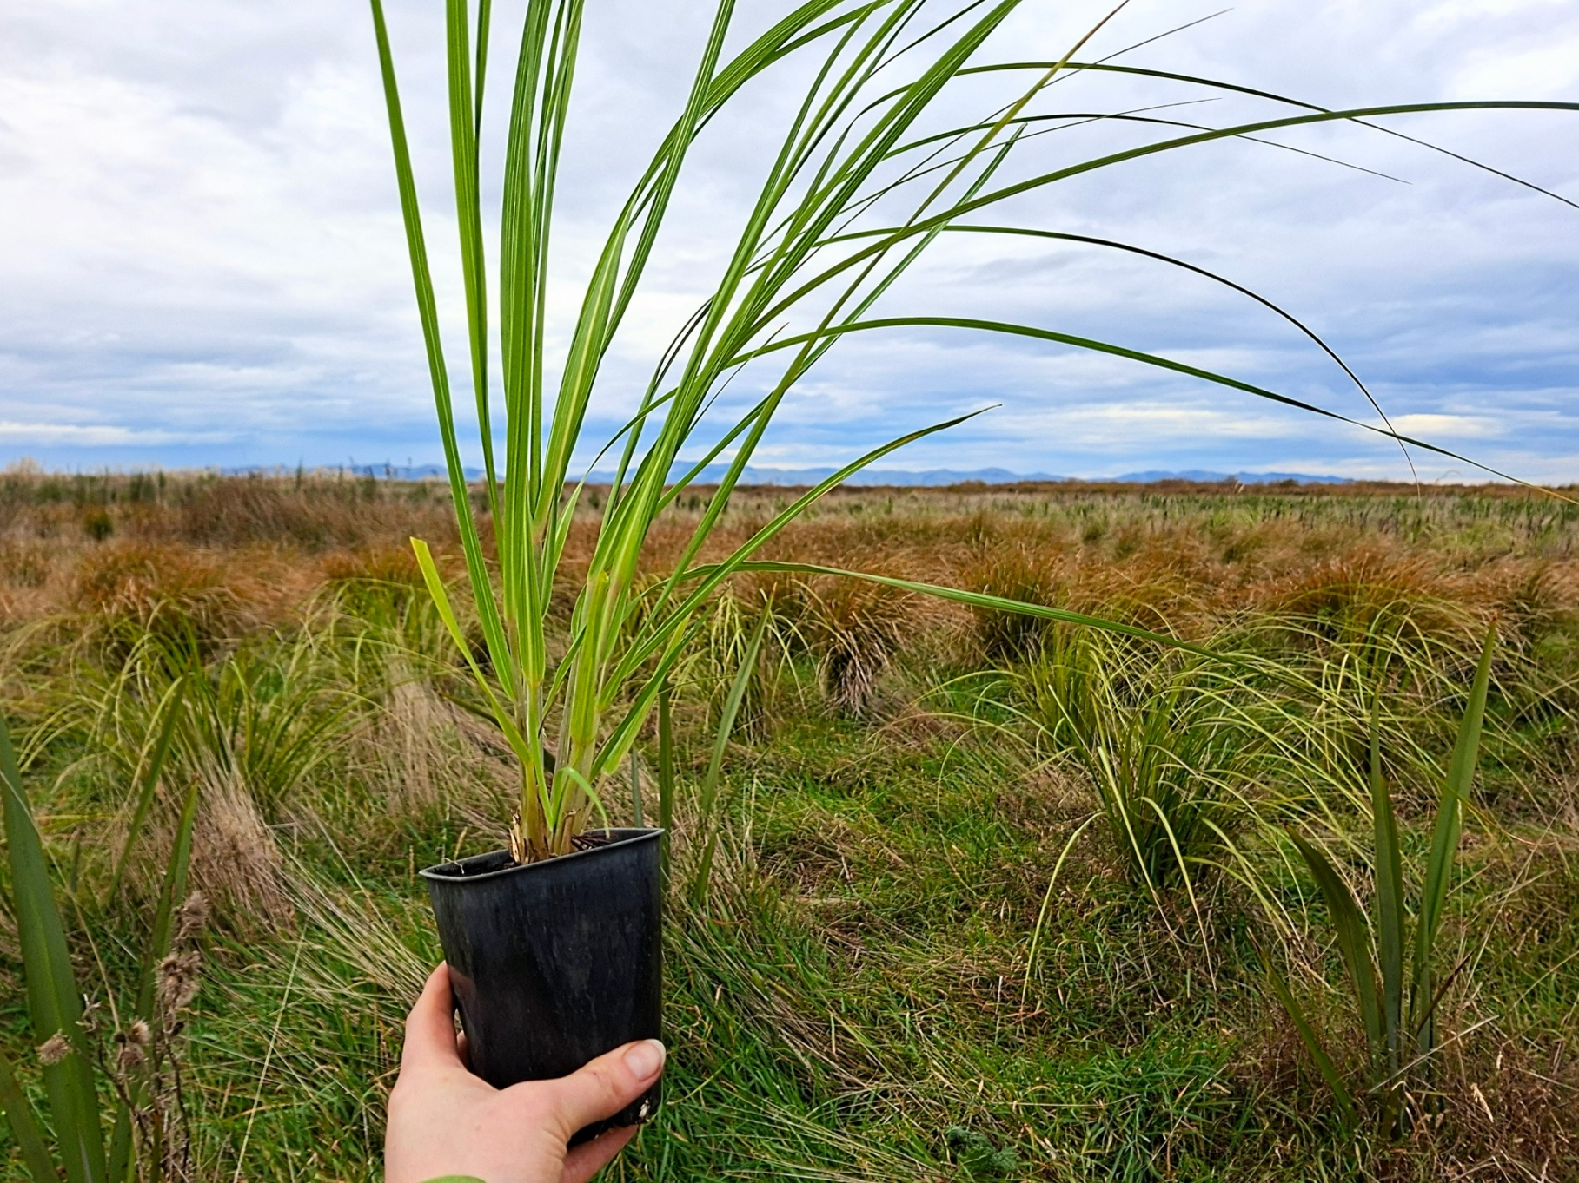
Canterbury Eco-sourced Plant Packages
Toetoe (Austroderia richardii) at Te Waihora – Lake Ellesmere Restoration Site 6 months old vs 2 years old Photo: © Jacque Bennett

Plant packages are a way of making restoration planting, easy, efficient and effective.
Plants selected for your plant package will be ecologically sourced from the nearest available remnant seed source to your planting site. These plants have adapted to local conditions and ensure a higher survival rate.
The species selected for these packages are tailored to a specific purpose. From Riparian/Streamside planting to erosion protection.
In order to keep things efficient and easy, our packages have a select number of species and utilise full grids of plants (so no dead space in your trailer).
The idea is to use the packages as a starting point, then other species (available at a reduced rate) can be added. We recommend adding additional species after the first 3 years. This will enhance your biodiversity and give more sensitive species shade and protection from the wind and frosts.
Plant packages are 1000-1004 plants and designed to be planted at 1.5m spacings.

Plant packages are $4,400.00 +GST per package
With the purchase of any of our packages, you can add additional plants from the recommended species list for $5 per plant for 1 year grow species and $6.50 for 2 year grow species. Please see plant package order form.

Plant package purpose: Riparian/Streamside/Wetland
Common name | Māori name | Species | Number of Plants
Ribbonwood | Mānatu | Plaginathus regius | 112
Cabbage tree | Tī kōuka | Cordyline australis | 128
Flax | Harakeke | Phormium tenax | 160
Toetoe | Toetoe | Austroderia richardii | 200
Cutty grass | Pūkio | Carex secta | 400
 |  | Total: | 1000

Recommended Riparian species available for $5 per plant
Common name | Māori name | Species
Karamū | Karamū | Coprosma robusta
Swap sedge | Pūkio | Carex virgata
Mingimingi | Mikimiki | Coprosma propinqua
Māori sedge | Pūrei/Pūkio | Carex maorica
Koromiko | Koromiko | Hebe salicifolia
Mānuka | Mānuka | Leptospermum scoparium
New Zealand Myrtle | Rōhutu | Lophomyrtus obcordata

Recommended Riparian species available for $6.50 per plant
Common name | Māori name | Species
White pine | Kahikatea | Dacrycarpus dacrydioides

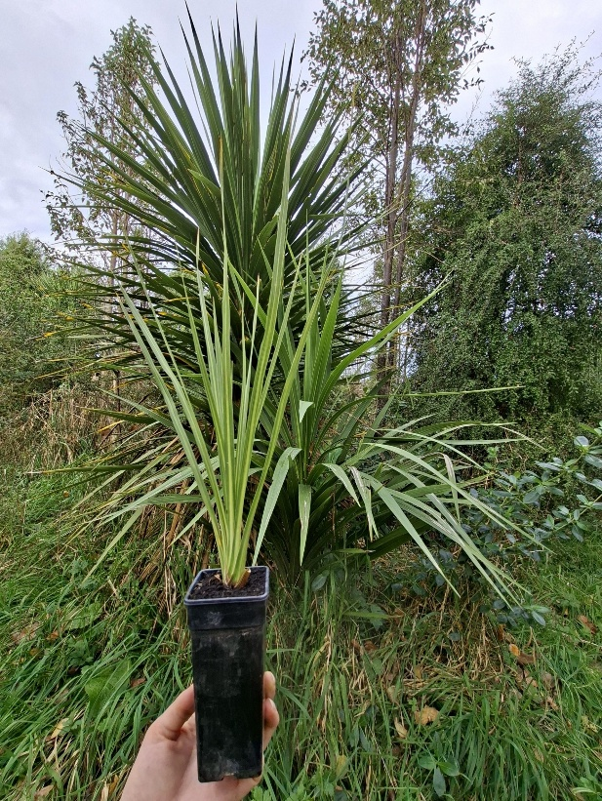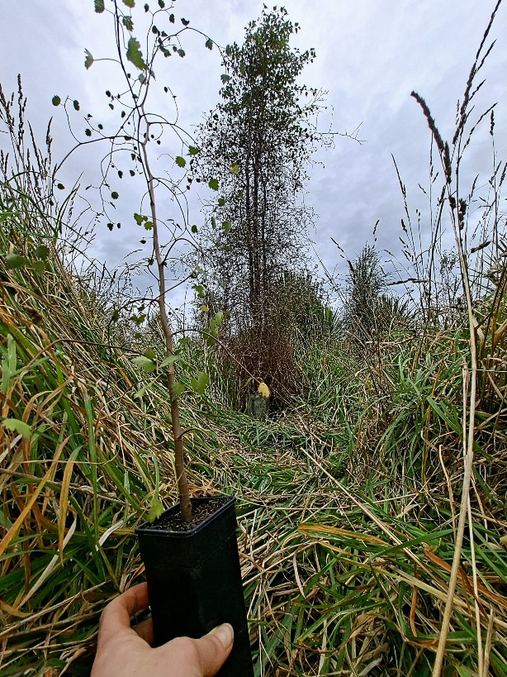
E.g. Growth of Ribbonwood - Mānatu - Plagianthus regius at Te Waihora restoration site 9 months vs 5 years Photo: © Jacque Bennett
E.g. Growth of Cabbage Tree -Tī Kōuka – Cordyline Australis at sheltered Te Waihora restoration site 7 months vs 4 years. Photo: © Jacque Bennett

Plant package purpose: Port Hills/Banks Peninsula Forest

(same species for Port Hills and Banks Peninsula – different eco sources)
Common name | Ingoa Māori | Species | Number of Plants
Lacebark | Houhere | Hoheria angustifolia | 160
Kānuka | Kānuka | Kunzea robusta | 192
Lemonwood | Tarata | Pittosporum eugenioides | 112
Kōhūhū | Kōhūhū | Pittosporum tenuifolium | 128
Shining Karamū | Karamū | Coprosma lucida | 128
Cabbage tree | Tī kōuka | Cordyline australis | 112
Ribbonwood | Mānatu | Plagianthus regius | 108
Lancewood | Horoeka | Pseudopanax crassifolius | 64
 |  | Total: | 1004

Recommended Port Hills/Banks Peninsula Forest species available for $5 per plant
Common name | Ingoa Māori | Species
Karamū | Karamū | Coprosma robusta
Mingimingi | Mikimiki | Coprosma crassifolia
Mingimingi | Mikimiki | Coprosma propinqua
5-Finger | Whauwhaupaku | Pseudopanax arboreus
Wineberry | Makomako | Aristotelia serrata
Ngaio | Ngaio | Myoporum laetum
Golden akeake | Akiraho | Olearia paniculata
Mountain akeake | Akeake | Olearia aviceniifolia
Koromiko | Koromiko | Hebe salicifolia

Recommended Port Hills/Banks Peninsula species available for $6.50 per plant
Common name | Ingoa Māori | Species
Kōwahi | Kōwhai | Sophora microphylla
Lancewood | Horoeka | Pseudopanax crassifolius
Tōtara | Tōtara | Podocarpus totara
Mataī | Mataī | Prumnopitys taxifolia
Broadleaf | Kāpuka | Griselinia littolralis
Wetland package Photo: © Jess Ward
Mānuka – Leptospermum scoparium Photo: © Jess Ward

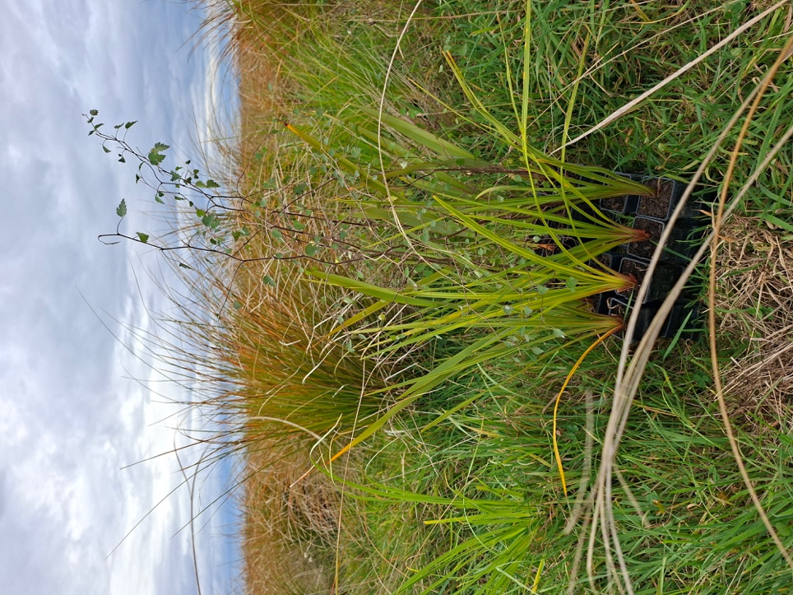
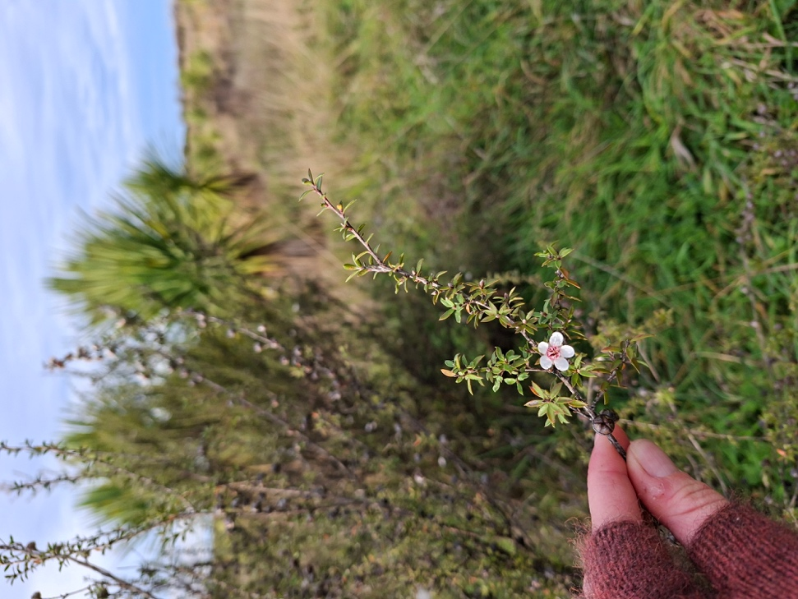

Plant package purpose: Plains Forest
Common name | Ingoa Māori | Species | Number of Plants
Kōhūhū | Kōhūhū | Pittosporum tenuifolium | 192
Lacebark | Houhere | Hoheria angustifolia | 112
Kānuka | Kānuka | Kunzea serotina | 256
Mingimingi | Mikimiki | Coprosma propinqua | 208
Golden ake ake | Akiraho | Olearia paniculata | 108
Cabbage tree | Tī kōuka | Cordyline australis | 128
 |  | Total: | 1004

Recommended Plains Forest species available for $5 per plant
Common name | Ingoa Māori | Species
Native broom | Makaka | Carmichaelia australis
Koromiko | Koromiko | Hebe salicifolia
Karamū | Karamū | Coprosma robusta
Mānuka | Mānuka | Leptospermum scoparium
Lemonwood | Tarata | Pittosporum eugenoides

Plant package purpose: Fire protection
Common name | Ingoa Māori |  | Species | Number of Plants
Karamū | Karamū |  | Coprosma robusta | 224
Lemonwood | Tarata |  | Pittosporum eugenoides | 96
Flax | Harakeke |  | Phormium tenax | 140
Korimiko | Koromiko |  | Hebe salicifolia | 80
Kōwhai | Kōwhai |  | Sophora microphylla | 96
Lacebark | Houhere |  | Hoheria angustifolia | 224
Wire vine | Pōhuehue |  | Muehlenbeckia complexa | 140
 |  | Total: |  | 1000

Recommended fire protection species available for $5 per plant
Common name | Ingoa Māori | Species
Mingimingi | Mikimiki | Coprosma propinqua
5-Finger | Whauwhaupaku | Pseudopanax arboreus
Whiteywood | Māhoe | Melicytus ramiflorus
Ngaio | Ngaio | Myoporum laetum
Red Matipo | Māpou | Myrsine australis
Ribbonwood | Mānatu | Plagianthus regius
Wineberry | Makomako | Aristotelia serrata
Kawakawa | Kawakawa | Piper excelsum

Recommended fire protection species available for $6.50 per plant
Common name | Ingoa Māori | Species
Lancewood | Horoeka | Pseudopanax crassifolius

Plant package purpose: Erosion protection
Common name | Ingoa Māori | Species | Number of Plants
Carex/Poa cita | Pūrei/Wī/Pātītī | Grasses/sedges (site specific) | 200
Toetoe | Toetoe | Austroderia richardii | 100
Cabbage tree | Tī kōuka | Cordyline australis | 64
Koromiko | Koromiko | Hebe salicifolia | 120
Lacebark | Houhere | Hoheria angustifolia | 64
Kānuka | Kānuka | Kunzea robusta/serotina (site specific) | 96
Flax | Harakeke | Phormium tenax | 200
Kōhūhū | Kōhūhū | Pittosporum tenuifolium | 80
Ribbonwood | Mānatu | Plagianthus regius | 80
 |  |  | 1004

Recommended erosion protection species available for $5 per plant
Common name | Ingoa Māori | Species
Cottonwood | Tauhinu | Ozothamnus leptophyllus
NZ Tea Tree | Mānuka | Leptospermum scoparium
Lemonwood | Tarata | Pittosporum eugenioides

Plant package purpose: Dryland
Common name | Ingoa Māori |  | Species |  | Number of Plants
Kānuka | Kānuka |  | Kunzea serotina or robusta |  | 344
Native broom | Mākaka |  | Carmichaelia australis |  | 80
Shrubby tororaro | Tororaro |  | Muehlenbeckia astonii |  | 100
Cottonwood | Tauhinu |  | Ozothamnus leptophyllus |  | 100
Mingimingi | Mikimiki |  | Coprosma crassifolia / propinqua |  | 336
Small-leaf tree daisy |  |  | Olearia adenocarpa |  | 20
Porcupine bush |  |  | Melicytus alpinus |  | 20
 |  | Total: |  | 1000

Recommended dryland species available for $5 per plant
Common name | Ingoa Māori | Species
Cabbage Tree | Tī kōuka | Cordyline australis
Golden akeake | Akiraho | Olearia paniculata

Starter Plant packages: Ideal for smaller properties or as a first step on your restoration journey.
These packages can be purchased for $460 + GST

Starter Riparian package:
Common name | Ingoa Māori |  |  |  | Species |  |  |  |  |  | Number of Plants
Ribbonwood | Mānatu |  |  |  | Plaginathus reguis |  |  |  |  |  | 16
Cabbage tree | Tī kōuka |  |  |  | Cordyline australis |  |  |  |  |  | 16
Flax | Harakeke |  |  |  | Phormium tenax |  |  |  |  |  | 20
Toetoe | Toetoe |  |  |  | Austroderia richardii |  |  |  |  |  | 20
Cutty grass | Pūkio |  |  |  | Carex secta |  |  |  |  |  | 20
 |  |  |  |  | Total: |  |  |  |  |  | 92

Starter Banks Peninsula/Port Hills package:
Common name | Ingoa Māori |  |  |  | Species |  |  |  |  |  | Number of Plants
Lacebark | Houhere |  |  |  | Hoheria angustifolia |  |  |  |  |  | 16
Kānuka | Kānuka |  |  |  | Kunzea robusta |  |  |  |  |  | 16
Lemonwood | Tarata |  |  |  | Pittosporum eugenioides |  |  |  |  |  | 16
Kōhūhū | Kōhūhū |  |  |  | Pittosporum tenuifolium |  |  |  |  |  | 16
Cabbage tree | Tī kōuka |  |  |  | Cordyline australis |  |  |  |  |  | 16
Ribbonwood | Mānatu |  |  |  | Plagianthus regius |  |  |  |  |  | 16
 |  |  |  |  | Total: |  |  |  |  |  | 96

Starter Plains Forest package:
Common name | Ingoa Māori |  |  |  | Species |  |  |  |  |  | Number of Plants
Kōhūhū | Kōhūhū |  |  |  | Pittosporum tenuifolium |  |  |  |  |  | 16
Lacebark | Houhere |  |  |  | Hoheria angustifolia |  |  |  |  |  | 16
Kānuka | Kānuka |  |  |  | Kunzea serotina |  |  |  |  |  | 16
Mikimikii | Mikimiki |  |  |  | Coprosma propinqua |  |  |  |  |  | 16
Golden akeake | Akiraho |  |  |  | Olearia paniculata |  |  |  |  |  | 16
Cabbage tree | Tī Kōuka |  |  |  | Cordyline australis |  |  |  |  |  | 16
 |  |  |  |  | Total: |  |  |  |  |  | 96

Starter Fire Protection Package:
Common name | Ingoa Māori |  |  |  | Species |  |  |  |  |  | Number of Plants
Karamū | Karamū |  |  |  | Coprosma robusta |  |  |  |  |  | 16
Lemonwood | Tarata |  |  |  | Pittosporum eugenioides |  |  |  |  |  | 16
Koromiko | Koromiko |  |  |  | Hebe salicifolia |  |  |  |  |  | 10
Lacebark | Houhere |  |  |  | Hoheria angustifolia |  |  |  |  |  | 16
Flax | Harakeke |  |  |  | Phormium tenax |  |  |  |  |  | 16
Wire vine | Pōhuehue |  |  |  | Muehlenbeckia complexa |  |  |  |  |  | 20
 |  |  |  |  | Total: |  |  |  |  |  | 94

Starter Erosion Protection Package:
Common name |  | Ingoa Māori |  |  |  | Species |  |  |  |  |  |  |  | Number of Plants
Toetoe |  | Toetoe |  |  |  | Austroderia richardii |  |  |  |  |  |  |  |  |  |  |  | 20
Cabbage Tree |  | Tī Kōuka |  |  |  | Cordyline australis |  |  |  |  |  |  |  |  |  |  |  | 16
Lacebark |  | Houhere |  |  |  | Hoheria angustifolia |  |  |  |  |  |  |  |  |  |  |  | 16
Kānuka |  | Kānuka |  |  |  | Kunzea robusta/serotina |  |  |  |  |  |  |  |  |  |  |  | 16
Kōhūhū |  | Kōhūhū |  |  |  | Pittosporum tenuifolium |  |  |  |  |  |  |  |  |  |  |  | 16
Ribbonwood |  | Mānatu |  |  |  | Plagianthus regius |  |  |  |  |  |  |  |  |  |  |  | 16
 |  |  |  |  |  | Total: |  |  |  |  |  |  |  |  |  |  |  | 100

Starter Dryland Package:
Common name |  | Ingoa Māori |  |  |  | Species |  |  |  |  |  |  |  |  | Number of Plants
Kānuka |  | Kānuka |  |  |  | Kunzea robusta/serotina |  |  |  |  |  |  |  |  |  |  |  | 16
Native Broom |  | Mākaka |  |  |  | Carmichaelia australis |  |  |  |  |  |  |  |  |  |  |  | 20
Shrubby Totoraro |  | Torotaro |  |  |  | Muehlenbeckia astonii |  |  |  |  |  |  |  |  |  |  |  | 20
Cottonwood |  | Tauhinu |  |  |  | Ozothamnus leptophyllus |  |  |  |  |  |  |  |  |  |  |  | 20
Mingimingi |  | Mikimiki |  |  |  | Coprosma crassifolia |  |  |  |  |  |  |  |  |  |  |  | 16
 |  |  |  |  |  |  |  | Total: |  |  |  |  |  |  |  |  |  | 92
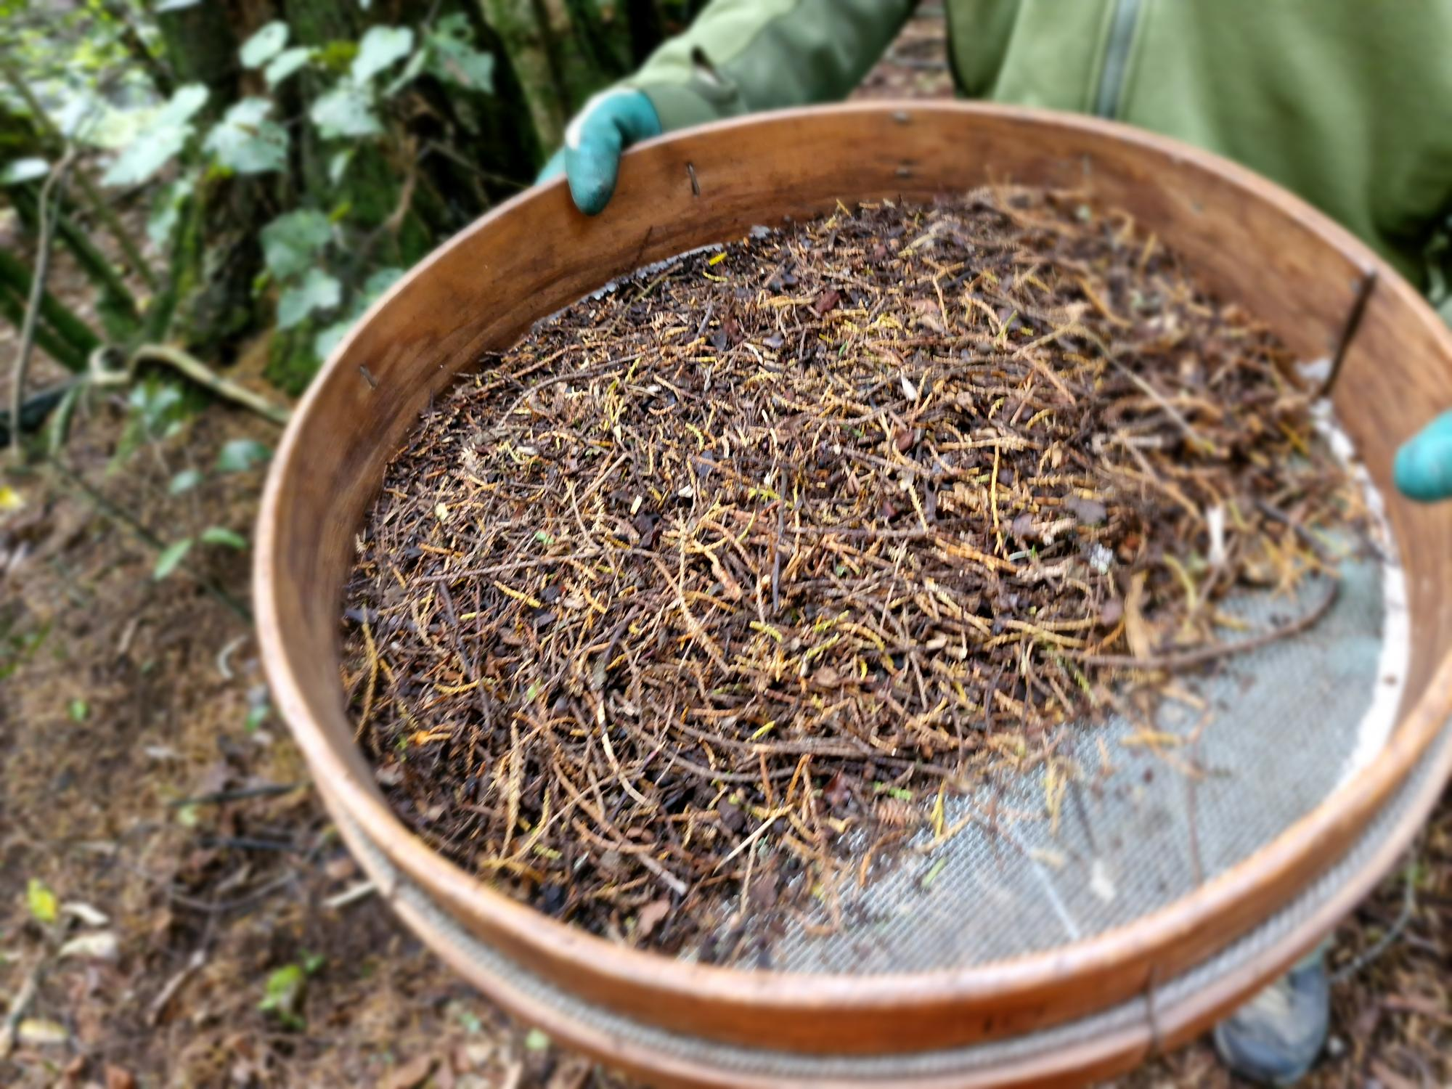
All plants grown at Motukārara Nursery are eco-sourced from your local ecosystem and remnant forests in your area.
mdjkf

Photo of Seed Collection sieve technique on Kahikatea (Dacrycarpus dacrydioides) Photo: © Andy Snook

