Plant Package Order Form 2027

Department of Conservation – Motukārara Wholesale Conservation Nursery
Minimum order $500
When completed, please email this form to motukarara@doc.govt.nz.
We will get back to you to confirm we have received your order within 2 weeks.

What you can expect:
- Eco sourced plants from Canterbury, for Canterbury – this ensures you get a better survival rate as plants have adapted to local conditions
- A plant that has been hardened off – Our plants are exposed to the elements and have their irrigation dialled back to make sure they can survive everything Canterbury has to offer.
- Plants are selected for strength, health, resilience and survivability – we want your planting to succeed so only provide you with high quality plants.
- We have a wide range of species available to order from.
- Our team of experts can help you choose the right plant, from the right place for the right purpose (whether that is for fire/flood mitigation, erosion control, increasing biodiversity, habitat creation, forestry, riparian management or carbon sequestration).
- Any plants bought through the Nursery directly support protecting and propagating threatened species in Canterbury and other local conservation work.
- You will receive a 5% discount if you order before 1st September 2026

Name
Planting site
Email
Phone
Required date (approximate month)

Plant package | Price + GST | Number of packages requested
Riparian/Streamside/Wetland Full package | $4,400 +GST
Riparian Starter pack | $460 + GST
Additional recommended species |  | Number of plants per species
Karamū - Coprosma robusta | $5 each
Swap sedge - Carex virgata | $5 each
Mingimingi - Coprosma propinqua | $5 each
Māori sedge - Carex maorica | $5 each
Koromiko - Hebe salicifolia | $5 each
Mānuka - Leptospermum scoparium | $5 each
NZ Myrtle - Lophomyrtus obcordata | $5 each
Kahikatea - D. dacrydioides | $6.50 each
 |  | Number of packages requested
Port Hills/Banks Peninsula Full package | $4,400 +GST
Port Hills/Banks Peninsula Starter package | $460 + GST
Additional recommended species |  | Number of plants per species
Karamū - Coprosma robusta | $5 each
Mikimiki - Coprosma crassifolia | $5 each
5 - Finger - Pseudopanax arboreus | $5 each
Wineberry - Aristotelia serrata | $5 each
Ngaio - Myoporum laetum | $5 each
Golden Akeake - Olearia paniculata | $5 each
Mountain Akeake - Olearia aviceniifolia | $5 each
Koromiko - Hebe salicifolia | $5 each
Kōwhai - Sophora microphylla | $6.50 each
Lancewood - Pseudopanax crassifolius | $6.50 each
Tōtara - Podocarpus totara | $6.50 each
Broadleaf - Griselinia littolralis | $6.50 each

Plant package | Price + GST | Number of packages requested
Plains Forest Full package | $4,400 +GST
Plains Starter pack | $460 + GST
Additional recommended species |  | Number of plants per species
Native broom - Carmichaelia australis | $5 each
Koromiko - Hebe salicifolia | $5 each
Karamū - Coprosma robusta | $5 each
Mānuka - Leptospermum scoparium | $5 each
Lemonwood - Pittosporum eugenoides | $5 each
 |  | Number of packages requested
Fire Protection Full package | $4,400 +GST
Fire Protection Starter pack | $460 + GST
Additional recommended species |  | Number of plants per species
Mingimingi - Coprosma propinquity | $5 each
5 Finger - Pseudopanax arboreus | $5 each
Māhoe - Melicytus ramiflorus | $5 each
Ngaio - Myoporum laetum | $5 each
Red Matipo - Myrsine australis | $5 each
Ribbonwood - Plagianthus regius | $5 each
Wineberry - Aristotelia serrata | $5 each
Kawakawa - Piper excelsum | $5 each
Lancewood - Pseudopanax crassifolius | $6.50 each
 |  | Number of packages requested
Erosion Protection Full Package | $4,400 +GST
Erosion Protection Starter Pack | $460 + GST
Additional recommended species |  | Number of plants per species
Cottonwood - Ozothamnus leptophyllus | $5 each
Manuka - Leptospermum scoparium | $5 each
Lemonwood - Pittosporum eugenioides | $5 each

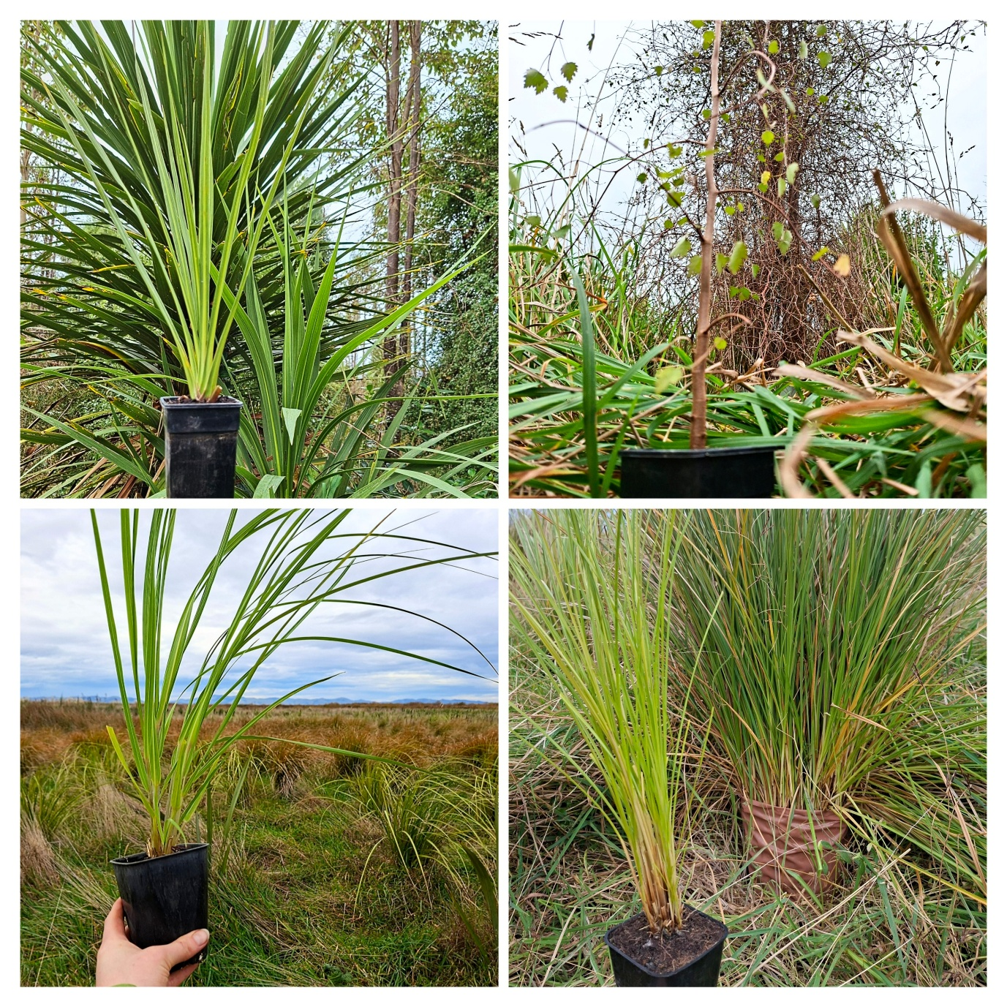

Plant package | Price + GST | Number of packages requested
Dryland Full package | $4,400 +GST
Dryland Starter pack | $460 + GST
Additional recommended species |  | Number of plants per species
Tī kōuka - Cordyline australis | $5 each
Golden Akeake - Olearia paniculata | $5 each

All plants are propagated at our nursery. They are available as long as stocks last. They are subject to shortages caused by circumstances beyond our control. We will confirm their availability.

The plants for sale have been selected to be of merchantable quality and true to name and description, but any expressed or implied conditions, statement or warranty in this respect is hereby excluded. See the full conditions of sale on our website here.

We love to re-use our containers! If you could - please drop the pots back to the nursery. Leave them outside the doors or pop them over the back fence if we are closed.
Thank you!

