

9i

Wildlife Act Consent (Section 71)
Application form 9i
This application form is for activities that involve protected wildlife which, under section 71 of the Wildlife Act 1953, require the consent of the Minister of Conservation and the Minister charged with the administration of the Act under which the activity or authority is performed or exercised (as per Schedule 9 of the Wildlife Act 1953).

Using this application form |   Application checklist  Have you included labelled attachments as required for your activities (including reports, maps, testimonials, and consultation documentation)?  Ensure these are attached/submitted with your application (see Section B: Activity, for more information).  Have you read the section regarding liability of the applicant for payment of fees?  Have you ensured you have any other necessary consents required (e.g., RMA consent)?  Have you signed your application (digitally or manually)?
Completing the application
Save – You can save this application form to your digital device and edit or complete it in your own time.
Fill – You can fill this application digitally using Microsoft word. If possible, we prefer you completed it this way, as it helps us process your initial application faster.
Print – You can print this application form and fill it manually, then scan it, or you can complete it digitally, then print it.
Submit – Either a hard copy at your local DOC District Office, or
Email – (Preferably) email your completed application and all the required labelled attachments to: permissions@doc.govt.nz

Important – Failure to complete this application form correctly may result in your application being returned to you seeking more information, which may extend the time it takes the Department of Conservation to process your application, or it may result in your application being declined. If you need help completing your application, please contact your local DOC office, or email permissions@doc.govt.nz
Navigation
Hints – Use the links through the hints column on the right hand side of the application form
Scroll – Simply use your mouse or keyboard arrows to scroll through the document page-by-page.

Before you start  Putting together a detailed application is greatly appreciated and allows the Department to process your application more effectively and efficiently. |  | Please take processing timeframes into consideration when submitting your application.
Process  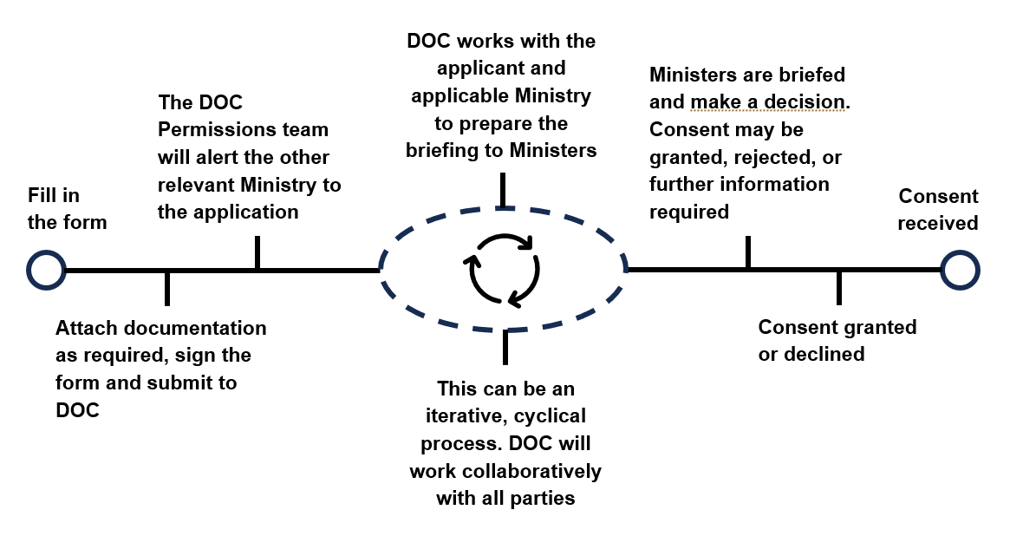 |  | An application is deemed complete when all information requested has been received.  Please see also the fees section.
Before Submitting
Before submitting your application, please ensure you have prepared the appropriate suplimentary documentation if required, and named them accordingly:
☐ Attachment B1.0 Project Background
☐ Attachment B2.0 Supplementary Information
☐ Attachment B3.1 Proposed Location
☐ Attachment B4.0 Restricted Lands
☐ Attachment B5.0 Proposed Wildlife
☐ Attachment B6.3 Wildlife Release Locations
☐ Attachment C7.0 Proposed measures to protect wildlife
☐ Attachment D1.0 Skills and Experience
☐ Attachment E1.0 Iwi Engagement
☐ Attachment E2.0 Other Consultation
SUBMIT via | permissions@doc.govt.nz

Section A | Applicant details
Organisation name (registered company, government department, other crown entity)  Legal status of Applicant: |  |  |  |  |  |  |  | Enter your details in the grey fields.
Registered company | Government department |  |  |  |  |  | Crown entity | Please attach a copy of Trust Deed (if applicable)
Other (please specify)
Registration number (if company)
Trading name (if different from applicant name)
Any previous Consents/Authorisations held? Yes No
If yes, please provide Consent/Authority number(s):
Postal address |  |  |  | Street address (if different from postal) |  |  |  | You must provide a New Zealand address for service.
Registered office of company or incorporated society (if applicable)
Phone |  |  |  |  |  | Website
Contact person:
What is their role:

Phone (direct dial preferred) |  |  |  |  |  | Mobile |  | Please fill these fields for your authorised contact person.
Email
Secondary Contact Person
This could be another person employed by your organisation or agent working on behalf of your organisation, such as a project ecologist, herpetologist, or other wildlife specialist.
Contact person:
What is their role:

Phone (direct dial preferred) |  |  |  |  |  | Mobile
Email

Section B | Understanding the overall project
- Project Background and Context  Please provide a Plain English summary of your project here, including project objectives.  1.1 What are the benefits of your project, and how is the project consistent with the purpose and objectives of the relevant Act under which you are authorised to operate (e.g., the Government Roading Powers Act 1989 or the Railways Act 2005)?  1.2 Do you consider the project:  - will be of national interest or importance?  - include any significant local environmental, social, or economic implications?  - will impact species listed in any NZTC lists under the super-category “Threatened” and the categories “Recovering”, “Relict”, “Naturally Uncommon”, “Data Deficient”, “Extinct”, or with a qualifier “Threatened Overseas”?  If yes, please provide additional information below.  1.3 If you need to include additional information regarding the above questions, please indicate this here:  ☐I have attached additional information in support of my application.  Please list any additional documents included with your application below. These are to be attached to your application and labelled Attachment B2.0 Supplementary Information.  - Consent term and activity timeframes  - Consent term  Consents will be granted for a limited term. State the start and end dates you would like your proposed consent to cover and explain why this term is sought. e.g., ‘10 years’ or ‘July 2025 – July 2035. | If you need more room, attach a copy of your project proposal to this form and label it Attachment B1.0 Project Background.
  Proposed term:
  Reason:
“NZTC list” means the most recent officially published list for any taxonomic group developed using the New Zealand Threat Classification System Manual by Townsend, et. al. (2008), or any successor document. To view the list, visit
our website.

- Proposed activity site(s)  Indicate what land your proposed activity includes:  ☐ Public Conservation Land (PCL) – if yes, complete questions 3.1, 3.2, and section B4 ‘Access to Restricted lands.’  ☐ Land not managed by the Department – if yes, complete questions 3.1 and 3.2  ☐ A mix of PCL and land not managed by DOC – if yes, complete questions 3.1, 3.2, and section B4 ‘Access to Restricted lands.’  - Activity site  Clearly identify the location/s in which your project will be carried out and why the locations/s are the best option. For all sites, include a map and GPS co-ordinates. Attach your map(s) and label them attachment B3.1 Proposed Location. | Use DOC Maps to view Conservation Land.  Wildlife Act authorities may apply to private land and public conservation land. If the location is private land, you will also need the consent of the landowner, or other appropriate access legislation (e.g., The Public Works Act 1981).
- Why these locations?  Clearly state why these locations/s are the best option. | For public conservation lands that require permission to enter, complete Part 4. Access to restricted lands, below.  Failure to complete section 4 may result in your application being returned to you seeking more information, which may extend the time required to process your application.  Use DOCgis to view and check the different status of Conservation Lands.  If proposing to undertake your activity in a National Park, your activity must be essential for the management, research, interpretation, or educational purposes of the park in question.
- Access to restricted lands
Special permission is required to enter some public conservation lands that have particularly high levels of protection. If you wish to enter land of any status listed below to carry out the proposed activity, select the status and state the full name of the land to which permission for access is sought. If you need more room to include a list of all restricted lands, attach a list and label it Attachment B4.0 Restricted Lands.
Nature reserve (s 20 Reserves Act 1977)
Name of land to be accessed:
Scientific reserve (s 21 Reserves Act 1977)
Name of land to be accessed

Specially protected area in a national park (s 13 National Parks Act 1980)
Name of land to be accessed

Wildlife sanctuary (s 9 Wildlife Act 1953)
Name of land to be accessed

Wildlife refuge (s 14 Wildlife Act 1953)
Name of land to be accessed

Section B (continued) | Wildlife your project will interact with
- State which wildlife protected under the Wildlife Act 1953 your project will interact with  List the common and scientific name/s and threat classification of all protected species for which the consent is sought.  Where possible, state the number of individuals of each species of protected wildlife to be caught, held or killled and what proportion of the local and national species population you estimate would be affected by your activity.  You can attach an additional list if more space is required. If you have the appropriate ecological or lizard management plan, attach it to this application and label it as Attachment B5.0 ‘ Proposed Wildlife’. |  | A guide to the New Zealand threat classification system can be found on the DOC website.
  Common English or Māori name | Scientific name | NZ threat clasification | # of individuals / Proportion of population
   |  | Choose an item.
   |  | Choose an item.
   |  | Choose an item.
   |  | Choose an item.
   |  | Choose an item.
- Activities you seek to undertake with wildlife
  - Actions
Select all the actions that are applicable to the activity you intend to carry out involving wildlife.
Catch alive and handle wildlife  Temporarily hold wildlife in possession  Liberate/release wildlife (either at project location/s, or at alternative location/s)  Hunt and/or kill wildlife  Take samples from wildlife  Take or destroy the eggs of wildlife  Mark – tag or attach identification or other scientific apparatus (including bands) to wildlife | *If you are seeking to transfer wildlife between location/s, see the guidance on the following page.
  Other:

Section B (continued) | Activities
  - Moving wildlife between location/s (salvage v translocation)
DOC currently differentiates between wildlife salvage and wildlife translocation. Please review the following criteria and indicate which, if any, applies to your project.
Salvage and transfer typically involves moving species under 500 metres from the project site/s. A salvage and transfer consists of four parts:
      - Assessment of the impacts of proposed developments on species and explorations of alternatives (e.g. avoidance of species habitat);
      - The planning and approval of salvage operations;
      - Preparing habitat release sites, capturing species at impact sites, temporary holding and care, data collection, transports to and release at sites; and
      - Post-release monitoring, contingency implementation as required, and reporting.
Translocations typically involves moving species more than 500 metres from the project site/s. Often, species are translocated between regions and/or islands.
Are you planning to salvage/transfer wildlife? | Yes | No
Are you planning to translocate wildlife? | Yes | No
DOC may determine that a translocation is the best course of action. You may be requested to provide additional information. A Conservation Translocation Case Manager will be assigned to provide advice and assistance throughout the application process.

  - Release site
If you are seeking to take wildlife from the project site/s and relocate and/or release this wildlife at other location/s, state:
- the location/s in which the wildlife will be relocated and/or released.
- briefly describe the location/s and size of the location/s, and
- how the release site meets the needs of the species being moved (e.g., food, habitat, breeding requirements, predator control)?
For specific sites, attach a map and label it Attachment B6.3 ‘Wildlife Release Locations.’ Alternatively, refer to this in your relevant ecological report or wildlife management plan (if attached).

Section C | Proposed measures to protect wildlife
Only provide information for the activities you are proposing to undertake. If you are not undertaking an activity, write ‘N/A’. If you need more room attach a separate document and label it Attachment C7.0 ‘Proposed measures to protect wildlife.’ Alternatively, refer to specific sections in your relevant ecological report or wildlife management plan (if attached).
- Effects on protected wildlife
List all actual and potential adverse effects the proposed activity will have on protected wildlife at the site.

- Methods to manage adverse effects protected wildlife
State what methods you will use to avoid or manage any adverse effects (actual or potential) the proposed activity will have on protected wildlife.
- Method(s) of capture
Describe the methods to be used to safely, efficiently, and humanely catch, hold, or kill the wildlife. Identify the relevant animal ethics processes you intend to use.
Section C (continued) | Proposed measures to protect wildlife
- Samples to be collected
  - Samples, amounts, methods
List exactly what samples are to be taken (e.g., blood, DNA, feathers, etc) and the methods/s to be used, including amounts to be taken (if known).
Sample | Method |  | Amount
  1.
2.

3.

- Purpose of collecting samples  State the purpose for which the samples would be taken (e.g., taxonomy, DNA sampling, disease screening) and if they will be sent overseas. |  |  |  |  | If you answer Yes to sending samples overseas, please download and complete Form9f see Application forms: Apply for permits
 |  | Intending to send overseas?
  Purpose.
 |  | Yes |  | No
- Marking, banding, tagging
  - Banding
Are you requesting to band wildlife? | Yes | No

  - Other marking
If you are proposing to mark wildlife with any other mark than a band, please describe the type of marking and details of the method to be used to attach it to ensure the animals’ health and safety.
Mark/tag to be fitted Method

Section D | Applicant skills and experience
Please provide relevant information relating to your ability to carry out the proposed activity (e.g. details of previous consents/authorisations, membership of professional organisations and relevant qualifications and experience). List full names of all individuals who will be involved in the activity. |  |  | Please attach details and label as Attachment D1.0 Skills and Experience
All individuals involved in activity
Full Names

Has the Applicant or any company directors, trustees, partners, or anyone involved with the application been convicted of any offence? | Yes | No
If yes please provide details:

Does the Applicant or any of the company directors, trustees, partners, or anyone involved with the Application have any current criminal charges pending before the court? | Yes | No
If yes please provide details:

Section E | Engagement
DOC has a responsibility to give effect to the principles of the Treaty of Waitangi (Treaty) in all the work we do. DOC engages with whānau, hapū and iwi to make informed decisions.We actively encourage you to engage directly with local iwi,hapū, prior to applying, and build ongoing relationships.  Please attach proof of all engagement e.g., email communications or project planning meeting minutes, include a list names and contact details of iwi hapu reps you have contacted, and label as Attachment E1.0 ‘Iwi Engagement’.  Please provide the names and details of any other supporting information, expert views, advice or opinions obained here. Please attach those additional written expert views, advice or opinions concerning your proposal to support the application and label them Attachment E2.0 ‘Other Consultation’. | If you are unsure of any consultation requirements for your proposal, please see the Engagement with Māori webpage or contact your local DOC office to discuss what is required.

Section F | Fees
Processing fees  Section 60B of the Conservation Act contains the statutory provisions regarding processing fees.  The Department recovers all direct and indirect costs to process applications regardless of whether the application is approved or declined. If at any stage an application is withdrawn, the Department will invoice the applicant for the costs incurred by the Department up to that point.  You may be required to pay a processing fee for this application regardless of whether your application is granted or not. Particularly complex applications may incur further costs – you will be sent an estimate of costs in this situation. We will contact you to advise if the fee is more than the estimated standard cost.  You may also request an estimate of the processing fees for your application at any point. If you request an estimate, DOC may require you to pay the reasonable costs of the estimate prior to it being prepared. DOC will not process your application until the estimate has been provided to you. Estimates are not binding.  DOC will invoice your processing fees after your application has been considered. If your application is large or complex, DOC may undertake billing at intervals periodically during processing until a decision is made.  The Department may obtain further information either from the applicant or from any other relevant source in order to process the application. The applicant will be advised of any information obtained from other sources. The cost of obtaining such information will be charged to and recovered from the applicant. The applicant will be informed as soon as practicable from receipt of the application if further information is required before this application form can be fully processed by the Department. | Applicants are required to pay the processing fees within 28 days of receiving an invoice. The Director-General is entitled to recover any unpaid fees as a debt.
Paying fees  The Department will ordinarily invoice the applicant for processing fees after a decision has been made on the application, but in some cases interim invoices will be issued. | If you are applying from outside New Zealand we can process a credit card payment – please contact us to request this procedure.
If you have a purchase order/number from an organisation registered with DOC please supply below.

Section G | Declaration
I certify that the information provided on this application form and all attached additional forms and information is to the best of my knowledge true and correct. |  | A Consent/ Authorisation may be varied or revoked if the information given in this application contains inaccuracies.
Signature (applicant) | Date (dd/mm/yyyy)
This application is made pursuant to Section 71 of the Wildlife Act 1953, and where applicable other relevant conservation legislation.
The purpose of collecting this information is to enable the Department to process your application. The Department will not use this information for any reason not related to that purpose.
Applicants should be aware that provisions of the Official Information Act may require that some or all information in this application be publicly released.

