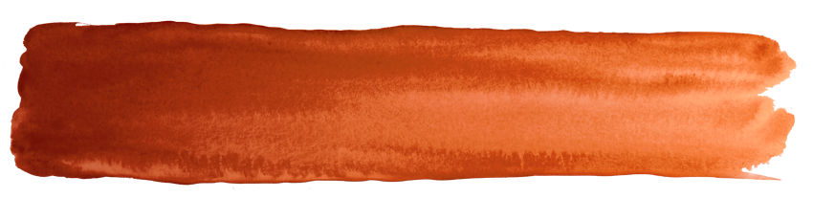

Submission Form
Draft Aoraki/Mount Cook National Park Management Plan

Once you have completed this form
Send by post to: Aoraki/Mount Cook NPMP Submissions, Department of Conservation, Private Bag 4715, Christchurch Mail Centre, Christchurch 8140 or email to: aorakinp@doc.govt.nz

Submissions must be received no later than 4.00 pm, Monday 4th February 2019
Anyone may make a submission, either as an individual or on behalf of an organisation. Please ensure all sections of this form are completed. You may either use this form or prepare your own but if preparing your own please use the same headings as used in this form. A Word version of this form is available on the Department’s website: www.doc.govt.nz/aoraki-mt-cook-plan-review

Submitter details:
Name of submitter
or contact person:
Organisation name:
(if on behalf of an organisation)
Postal address:

Telephone number:
(the best number to contact you on)
Email:
I wish to be heard in support of my submission (this means you can speak at a hearing)
I do not wish to be heard in support of my submission
(tick one box)
Signature:
Your submission is submitted as part of a public process and once received by the Department it is subject to the provisions of the Privacy Act 1993 and the Official Information Act 1981. The Department may post your submission on its website and also make it available to departmental staff, any consultant used, the relevant Conservation Board and the New Zealand Conservation Authority. Your submission may be made available to any member of the public following a request made under the Official Information Act 1981.
Submission:

Section:  Identify the section, objective, outcome, policy, milestone, table or map that your submission relates to. | Submission:  Explain the nature of your submission stating whether you support or oppose the approach in the draft Plan. Please provide brief reasons. | Decision sought:  State clearly the decision sought or changes you would like to see. Please be as precise as possible. For example:  - if supporting: ‘retain Policy X’  - if opposing: ‘delete Policy X’  - if seeking changes ‘reword Policy X to read (give suggested wording)
Please continue on a separate sheet if required.

Further information can be appended to your submission. If you are sending this submission electronically we accept the following formats – Microsoft Word, Text, PDF and JPG. The file must not be more than 30 MB – please send large attachments separately or contact aorakinp@doc.govt.nz to arrange for delivery of large electronic files.

