Assessment of Mark-Recapture Sample Size Effects on Demographic Rate Estimation of white-capped Albatross
Simulation Modelling
DRAFT COPY
Prepared for Department of Conservation
June 2015

Prepared by:
Jim Roberts
Ian Doonan
David Thompson
For any information regarding this report please contact:
Jim Roberts

Fisheries Modelling
+64-4-386 0867
jim.roberts@niwa.co.nz

National Institute of Water & Atmospheric Research Ltd
Private Bag 14901
Kilbirnie
Wellington 6241
Phone +64 4 386 0300
NIWA CLIENT REPORT No: XXXX
Report date: June 2015
NIWA Project: DOC15306

Contents

Executive summary 4
1 Introduction 5
2 Methods 5
2.1 Modelling approach 5
2.2 Input Values 6
3 Results 8
4 Discussion 11
5 Acknowledgements 11
6 References 11

Figures
Figure 3-1: Parameter estimates (left) and associated c.v. (right) with different scenarios of numbers of banded individuals in the initial study year (top = 150 individuals; middle = 300; bottom = 600) and number of years with resighting effort (each bar represents a different value). 9
Figure 3-2: The c.v. associated with adult survival estimates with different scenarios of numbers of banded individuals in the initial study year (150, 300 or 600 individuals) and subsequent number of years with resighting effort (2-10 years). 10
Figure 3-3: Parameter estimates (left) and associated c.v. (right) with different scenarios of resighting probability for breeders and non-breeders. 10

Reviewed by and Approved for release by

XXXX

Executive summary

- Disappointment Island, within the Auckland Islands group, supports over 70,000 breeding pairs of white-capped albatrosses Thalassarche cauta steadi annually, the largest colony of New Zealand’s most abundant albatross species. This species interacts with commercial fisheries and ranks highly within the Level 2 Seabird Risk Assessment process, but with a relatively high level of uncertainty around the estimate of adult survival.
- A study was undertaken to assess the effect of alternative mark-recapture sampling approaches to a potential mark-resighting study of white-capped albatross on the estimation of demographic rates.
- A data simulator was used to create dummy mark-resighting observations for a single banding year with alternative scenarios of: banded sample size (150, 300 or 600 breeding individuals); number of subsequent consecutive resighting years (2, 3, 4, 5 or 10 years); and resighting probability of breeders (0.6 or 0.4) and non-breeders (0.0 or 0.1).
- The SeaBird demographic modelling software was then used to determine variability in the estimates of survival and breeding rate using the dummy mark-resighting observations. This assessment assumed that demographic rates were constant with respect to year and age and variability of demographic rates of wild populations are likely to be greater than those obtained by this assessment.
- Increasing the banded sample size from 150 to 600 individuals led to an increase in the precision (c.v.) of annual survival breeding rate estimates.
- With an input survival rate of 0.95 and a banded population of 150 individuals, the range of survival estimates was wide with 5 years of resighting effort (range from 0.91-0.99, x̅ = 0.95), though was much narrower with 10 years of resighting effort (0.93-0.96, x̅ = 0.95). With a banded sample size of 600 individuals, the range of survival estimates was narrow with 5 years of resighting effort (0.93-0.97, x̅ = 0.95).
- The precision of demographic rate estimates was not greatly affected by reducing the resighting probability of breeders from 0.6 to 0.4, though reducing the resighting probability of non-breeders from 0.10 to 0.00 produced imprecise estimates that were for some samples very different from input values.
- To produce estimates of demographic rates that would be suitably precise for risk assessment purposes, this data simulation approach indicates that resighting effort over 5-10 years would be required subsequent to banding of a population between 150-600 individuals. In a wild population, demographic rates are likely to change through time, so that greater sampling effort (in terms of banded individuals, number of resighting years or even resighting effort) may be required.

Introduction
White-capped albatross Thalassarche cauta steadi is endemic to New Zealand and breeds almost exclusively at the Auckland Islands, where Disappointment Island holds the majority (ca. 95%, Baker et al. 2014) of the breeding population. This taxon is currently classified as ‘At Risk – Declining’ (Robertson et al. 2013), although Baker et al. (2014) concluded that there was no clear evidence for a systematic monotonic decline in the breeding population over the eight years (2006 to 2013) of their aerial survey study. Nevertheless, white-capped albatross ranks very highly within the Level 2 Seabird Risk Assessment process (Richard & Abraham 2013), with a relatively high level of uncertainty around the estimate of adult survival.
This project seeks to establish whether a study population of white-capped albatross could be developed at Disappointment Island that will enable key life-history parameters to be robustly estimated, with a particular, but not exclusive, focus on adult survival. While white-capped albatross breeds at other sites within the Auckland Islands, only the large population at Disappointment Island is readily and easily accessible, is free of introduced mammalian pests (feral pigs Sus scrofa are present on main Auckland Island and regularly destroy accessible nests and nest contents) and represents the only practicable and viable location for such a study population. Previously, a study population was established at South West Cape, on main Auckland Island, at a site that was accessible to field workers with the aid of a rope ladder, but which was inaccessible to pigs. However, the study site was relatively small and supported a correspondingly modest number of breeding birds: a total of 122 banded birds were available for mark-recapture analyses over four years of resighting effort (Francis 2012). Demographic parameters were estimated from this small study population, but confidence intervals were relatively large. For example, adult survival was estimated at 0.96, with 95% confidence intervals of 0.91-1.00, and the annual probability of breeding was estimated at 0.68, with 95% confidence intervals of 0.58-0.81 (Francis 2012).
For this study, we conducted demographic assessments using simulated mark-resighting data to assess the precision of demographic rate estimates that might be expected given a particular mark-resighting methodology (i.e. number of banded individuals and subsequent resighting years).

Methods

Modelling approach
A two-phase modelling analysis was adopted for this assessment:
- A data simulator was used to create dummy mark-resighting observations for a given number of individuals in a single banding year (150, 300 or 600 individuals) and alternative scenarios of number of subsequent years with resighting effort (2-10 years), given a user-specified set of input values of annual survival, breeding and resighting probabilities.
- Outputs from the data simulator were then used by a demographic assessment model (SeaBird) to generate estimates of annual survival, breeding and resighting probabilities.
Twenty simulated data sets were generated for each configuration of parameter values and sample sizes and the 95% CI calculated.
The data simulator produced observations in a format that could be used by SeaBird. The data simulator was developed in R and observations were produced in two steps: 1) a Leslie matrix model was used to generate annual mark-resighting observations for each individual banded in the initial year, given a set of demographic rates, assuming that all individuals that were still alive in a given year were observed; 2) a proportion of the resighting observations were then marked as not seen in a year in accordance with the resighting probability. The statistical distribution used was the binominal for both resighting and survival.
The SeaBird model partition was comprised of two classes: breeders and non-breeders (each a plus group i.e., demographic rates were constant with respect to age). Transition probabilities between states were given by the annual probability of breeding for individuals that bred or did not breed in the previous year and of survival. In addition state-dependent resighting probability was estimated separately for breeders and non-breeders in the current year. Thus, five parameters were estimated (respective values used by the data simulator in parentheses):
- Surv (0.95) – the annual probability of survival;
- Prbb (0.2) – probability of breeders in year-1 breeding in the current year;
- Prnb (0.8) – probability of non-breeders in year-1 breeding in the current year;
- Resb (0.6, 0.4 used in a sensitivity run) – the annual resighting probability of breeders;
- Resn (0.1, 0.0 used in a sensitivity run) – the annual resighting probability of non-breeders.

Input Values

Number of breeding birds banded
The reference number (150) reflects the number of breeding birds banded in 2015 (Thompson et al. 2015). Simulations where this number is doubled, and then doubled again reflect reasonable and achievable banded totals of breeding birds at Disappointment Island.

Years of resighting effort
Simulations were run for two, three, four, five and ten years of resighting effort, with the reference set at five years. Five years was selected as being both realistic and achievable given the number of annual visits to the Auckland Islands (at least 20 consecutive years and ongoing) for a range of research activities, onto which white-capped albatross resighting work could be added, with ten years as a possible target should the current interest in Auckland Island research be maintained.

Annual survival (surv)
We use a reference value of 0.95 for adult annual survival. This is realistic given earlier estimates for white-capped albatross (0.96, Francis 2012), and very similar estimates for other species of albatross (for example, Waugh et al. 1999, Converse et al. 2009, Francis & Sagar 2012).

Annual breeding rate (Prbb and Prnb)
This is the probability of a bird breeding in year-1 then breeding in year0 (Prbb), and similarly the probability of a non-breeding bird in year-1 breeding in year0 (Prnb). In annual species, the proportion of breeding birds in one year that choose to breed in the following year, regardless of whether that breeding attempt was successful or not, is generally very high. For example, in black-browed albatrosses Thalassarche melanophris in the Falkland Islands only approximately 6% of breeding birds chose not to breed the following year (Catry et al. 2011). For biennial species, successful breeders in one year tend not to breed the following year, whereas failed breeders (which fail relatively early in the breeding season) and breeders that are not breeding in a particular year usually breed the following year. For example, an estimated 6% of breeding grey-headed albatrosses T. chrysostoma in year-1 also bred in year0, whereas 84% of non-breeding birds in year-1 chose to breed in year0 (Converse et al. 2009). Francis (2012) concluded that white-capped albatross was intermediate between biennial and annual breeding species. Here we have adopted annual breeding rate reference values of 0.2 and 0.8 for birds that were breeders and non-breeders in year-1, respectively. These values are towards the biennial end of the breeding strategy spectrum for albatrosses and as such are conservative in the sense that if white-capped albatross are in fact more annual-like than we have assumed, then the resighting of individuals will be greater than we have estimated.

Annual resighting probability for breeding birds (Resb)
This parameter reflects the likelihood of being able to detect a banded bird should that bird be breeding in a given year, and incorporates realistic logistic constraints of being able to spend time (effort) at Disappointment Island. Currently, only one member of 150 pairs of breeding white-capped albatrosses has been banded (hence overall banded total of 150 individuals). Therefore, there would be, on average, a 50% chance of the banded bird from a pair being present on the nest during the incubation or guard stages of the breeding season (when any resight work would be undertaken). As banded partners of land-based birds return to the colony, to take over incubation or guarding duties, the proportion of the marked population resighted will increase. The rate at which birds change-over at active nests will reflect in part the duration of foraging trips, which for white-capped albatrosses during the guard stage are approximately two days (Torres et al. 2011), but longer (in some cases over two weeks) during the incubation phase (Thompson et al. unpublished data). Resighting probability data for nesting albatrosses are scarce, but for Buller’s albatross Thalassarche bulleri at the Snares, 75-80% of banded breeding birds are resighted over a period of up to one week of effort (P. Sagar pers.com). Here we have adopted a value of 0.6, less than would be expected for Buller’s albatross, reflecting the less-frequent change-overs in white-capped albatross, and additionally the greater logistic constraints in working at Disappointment Island compared to the Snares.

Annual resighting probability for non-breeding birds (Resn)
Analogous to the resighting probability for breeding birds above, this parameter reflects the likelihood of being able to detect a banded bird should that bird be non-breeding in a given year, and again incorporates realistic logistic constraints of being able to spend time (effort) at Disappointment Island. Non-breeding albatrosses (i.e. birds that have bred previously, but which skip breeding in some years) are not constrained to return to the breeding colony and typically, but especially in biennially-breeding species, may not be present at the breeding colony during the breeding season (Mackley et al. 2010). The majority (approximately 80%) of white-capped albatrosses remain in Australasia year-round, and even those that migrate to waters off South Africa during the non-breeding period return to New Zealand over the summer (Thompson et al. unpublished data). Non-breeding white-capped albatrosses have been observed at South West Cape occupying nest sites used in previous years. Here we adopt a reference value of 0.1 to reflect the relatively low probability of sighting non-breeding birds at the breeding colony, even when wearing a relatively large and uniquely-numbered plastic leg band.
All individuals were assigned as breeders in the initial banding year. Demographic rates were assumed to be constant with respect to resighting year and the time period over which rates were estimated varied with the number of years of resighting effort. The mean, range and c.v. of parameter estimates were reported for 20 samples of dummy mark-recapture observations generated by the data simulator.

Results
The close proximity of the mean parameter estimates obtained from the demographic assessment to values used to generate the dummy observations suggests that there were no major biases in the estimation of parameters that might relate to model structures of the data simulator or the demographic assessment model (Figure 3-1).
Increasing the banding sample size (from 150 to 600 individuals) or the number of consecutive resighting years subsequent to banding led to an increase in the precision of all estimated parameters (Figure 3-1, right-hand plot). Focussing on annual survival estimates, with a banded population of 150 individuals the range of estimates obtained (across 20 samples of mark-resighting observations) was quite large even with 5 years of resighting effort (range from 0.91-0.99, x̅ = 0.95), though this was greatly reduced with 10 years of resighting effort (0.93-0.96, x̅ = 0.95). With a banded sample size of 600 individuals, the range of estimates was quite small with just 5 years of resighting effort (0.93-0.97, x̅ = 0.95). The rate of decrease in the c.v. of survival estimates was greatest in first 2-4 years of consecutive resighting effort after banding (for 150 to 600 banded individuals), with relatively smaller decreases in c.v. with additional years of effort (Figure 3-2).
The precision of breeding rate estimates was lower than that of survival for a given number of banded individuals or number of resighting years (Figure 3-1). A large increase in the precision of breeding rate (and survival) estimates was obtained when increasing the number of resighting years from 2 to 3 years. However, beyond 3-years of resighting effort, the precision of breeding rate estimates appears to be more sensitive to increasing banded sample size than to additional resighting years relative to survival estimates (from a visual inspection of Figure 3-1).
The precision of survival estimates was reduced slightly by reducing the resighting probability of breeders from 0.6 to 0.4 (from 2.3 to 3.9 for a banded sample of 150 individuals). Reducing the resighting probability of non-breeders from 0.10 to 0.00 produced precise estimates of survival (c.v. = 1.9), though led to a strong positive bias in survival estimates (13 out of 20 samples were at the upper bound of 1.00) and also led to breeding rate estimates that were very different from the input values (Figure 3-3).
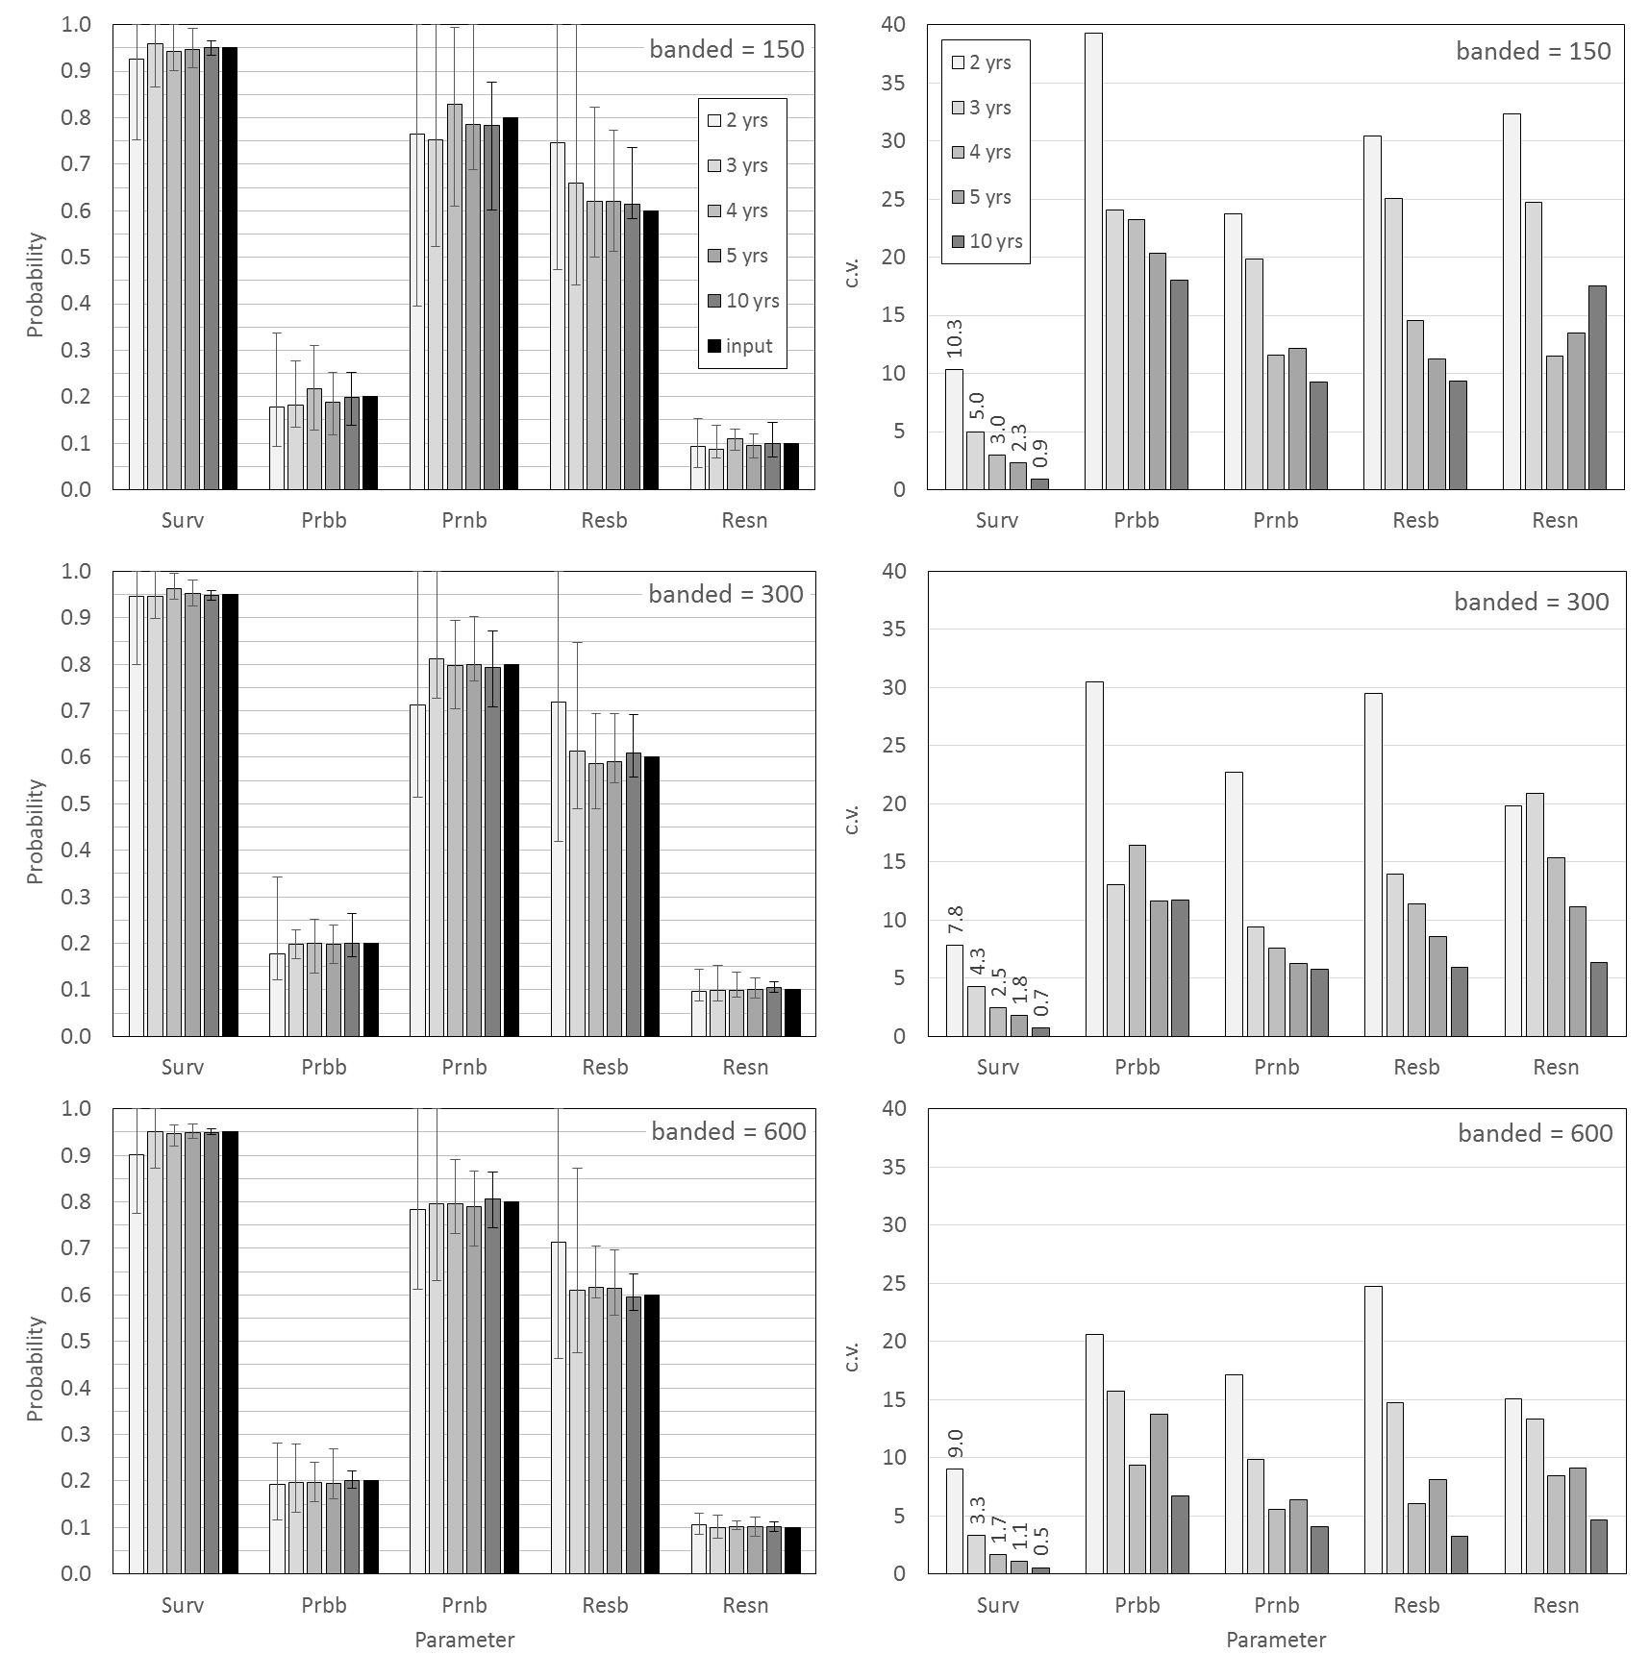
Figure 3-1: Parameter estimates (left) and associated c.v. (right) with different scenarios of numbers of banded individuals in the initial study year (top = 150 individuals; middle = 300; bottom = 600) and number of years with resighting effort (each bar represents a different value).
Bars and error bars on left-hand plot represent the mean and range of estimates. Parameter names annotated as “Surv” – annual probability of survival, “Prbb” – probability of breeders in year-1 breeding in the current year, “Prnb” – probability of non-breeders in year-1 breeding in the current year, “Resb” – the annual resighting probability of breeders, “Resn” – the annual resighting probability of non-breeders.

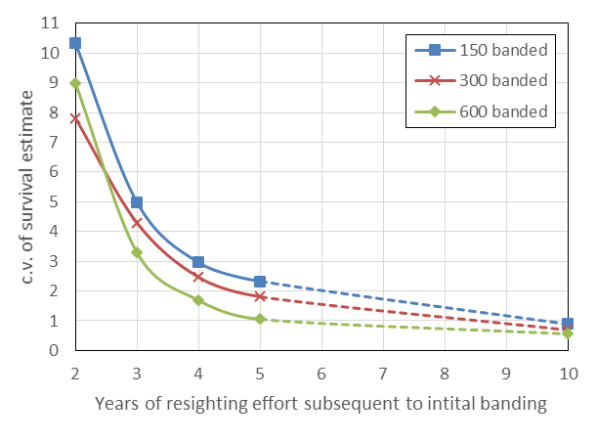
Figure 3-2: The c.v. associated with adult survival estimates with different scenarios of numbers of banded individuals in the initial study year (150, 300 or 600 individuals) and subsequent number of years with resighting effort (2-10 years).

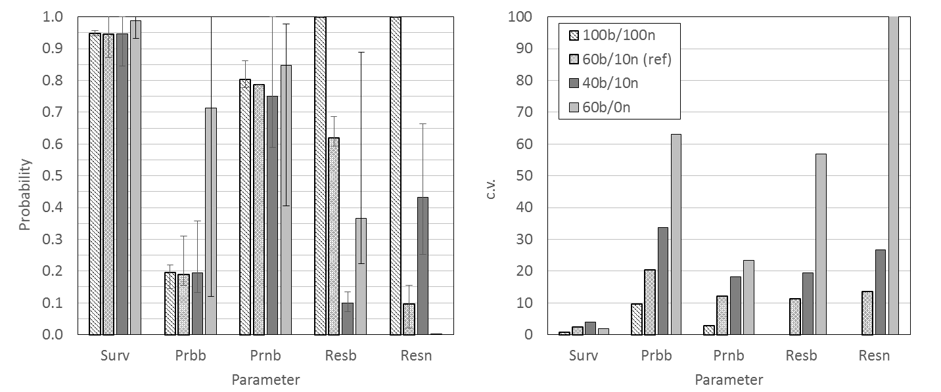
Figure 3-3: Parameter estimates (left) and associated c.v. (right) with different scenarios of resighting probability for breeders and non-breeders.
Banded sample size = 150; 5 years of resighting effort; bars and error bars on left-hand plot represent the mean and range of estimates. Parameter names annotated as “Surv” – annual probability of survival, “Prbb” – probability of breeders in year-1 breeding in the current year, “Prnb” – probability of non-breeders in year-1 breeding in the current year, “Resb” – the annual resighting probability of breeders, “Resn” – the annual resighting probability of non-breeders; legend of right-hand plot annotated as “100b/100n” – 100% annual resighting probability of breeders and non-breeders, “60b/10n” – 60% resighting probability of breeders and 10% of non-breeders (reference run), “40b/10n” – 40% resighting probability of breeders and 10% of non-breeders, “60b/0n” – 60% resighting probability of breeders and 0% non-breeders.

Discussion
There are a number of limitations to this study, e.g. we assumed that demographic rates were constant with respect to year, whereas they would likely be year-varying in a wild population. As such, the estimates of precision reported here are likely to be low relative to what would actually be observed. In addition, only a single banding year was used, though multiple banding years are typically attempted for a study population. Note that the data simulator can be configured to produce multiple years of banding effort with associated resighting observations.
To produce estimates of demographic rates that would be suitably precise for risk assessment purposes, the approach adopted here indicates that resighting effort over 5-10 years would be required subsequent to banding of a population between 150-600 individuals. In a wild population, demographic rates are likely to change through time, such that greater sampling effort (in terms of banded individuals, number of resighting years or even resighting effort) may be required. Much longer time series of resighting effort may be required to obtain similarly precise estimates of breeding rate.
The very poor estimation of demographic rates when adopting a zero resighting probability of non-breeders suggests that a suitable amount of effort should be expended on resighting non-breeding individuals that have been banded as part of the mark-resighting study.
The modelling approach used in this study is sufficiently flexible to allow analogous mark-recapture sampling method assessments for any species for which a mark-recapture study may be desirable, i.e., need not be limited to seabird species). This study considered the effects of banded sample size and years of resighting effort on the precision of demographic parameter estimation. Further studies could simultaneously consider the effects of varying resighting probability, of multiple banding years and of species with different reproductive strategies (e.g. annual v biennial breeders, through alteration of relative breeding rates of those that did or did not breed in the previous year). Also, the simulator could use distributions other than the binomial distribution, that have more errors and perhaps some process error between years to explore a wider range of variability. These assessments can be tailored to the reproductive biology and sampling constraints specific to a particular study population.

Acknowledgements
We would like to thank the Conservation Services Programme (CSP) of the Department of Conservation and the CSP technical working group for funding and reviewing this study.

References
Baker, G.B.; Jensz, K.; Cunningham R. (2104). White-capped albatross aerial survey 2014: Final Report. Prepared for Conservation Services Programme, Department of Conservation, Wellington.
Catry, P.; Forcada, J.; Almeida, A. (2011). Demographic parameters of black-browed albatrosses Thalassarche melanophris from the Falkland Islands. Polar Biology 34: 1221-1229.
Converse, S.J.; Kendall, W.L.; Doherty, P.F.; Ryan, P.G. (2009). Multistate models for estimation of survival and reproduction in the grey-headed albatross (Thalassarche chrysostoma). Auk 126: 77-88.
Francis, R.I.C.C. (2012). Fisheries risks to the population viability of white-capped albatross Thalassarche steadi. New Zealand Aquatic Environment and Biodiversity Report No. 104. Ministry for Primary Industries, Wellington. 24p.
Francis, R.I.C.; Sagar, P.M. (2012). Modelling the effect of fishing on southern Buller’s albatross using a 60-year dataset. New Zealand Journal of Zoology 39: 3-17.
Mackley, E.K.; Phillips, R.A.; Silk, J.R.D.; Wakefield, E.D.; Afanasyev, V.; Fox, J.W.; Furness, R.W. (2010). Free as a bird? Activity patterns of albatrosses during the nonbreeding period. Marine Ecology Progress Series 406: 291-303.
Richard, Y.; Abraham, E.R. (2013). Risk of commercial fisheries to New Zealand seabird populations. New Zealand Aquatic Environment and Biodiversity Report No. 109. Ministry for Primary Industries, Wellington. 58p.
Robertson, H.A., Dowding, J.E., Elliott, G.P., Hitchmough, R.A., Miskelly, C.M., O’Donnell, C.F.J., Powlesland, R.G., Sagar, P.M., Scofield, R.P., Taylor, G.T. (2013). Conservation status of New Zealand birds, 2012. New Zealand Threat Classification Series 4, Department of Conservation, Wellington, 22p.
Thompson, D.; Parker, G.; Rexer-Huber, K.; Sagar, P. (2015). Feasibility of monitoring white-capped albatross at Disappointment Island. Unpublished report to the Conservation Services Programme, Department of Conservation, Wellington. 8p.
Torres, L.G.; Thompson, D.R.; Bearhop, S.; Votier, S.; Taylor, G.T.; Sagar, P.M.; Robertson, B.C. (2011). White-capped albatrosses alter fine-scale foraging behaviour patterns when associated with fishing vessels. Marine Ecology Progress Series 428: 289-301.
Waugh, S.M.; Weimerskirch, H.; Moore, P.J.; Sagar, P.M. (1999). Population dynamics of black-browed and grey-headed albatrosses Diomedea melanophrys and D. chrysostoma at Campbell Island, New Zealand, 1942-96. Ibis 141: 216-225.

